Fordbank Residents Association – Website and Logo Meeting
24th April 2014
62 Ford Lane 7.15pm
Present:
Ford Lane: Rachel Woods (46), Tony Butterworth (62).
Dene Road: Roger Platford (59), Shaun (81)

- Welcome.
TB thanked Roger and Shaun for attending the meeting and set out that the RA needed help in maintaining the website which had been created by Tom Butterworth, but needed to move from the basic site to a more comprehensive model. The RA Committee had also voted on their choice of the logo from the range of designs sent by Shaun.

- Logo.
This was agreed to be this one:

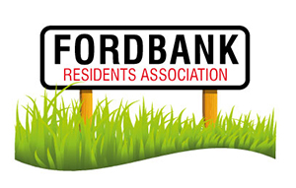
- Website.
Tom Butterworth had designed the website using wordpress and is still happy to continue to host it. TB gave Shaun all the relevant passwords and log in details. Shaun stated this was the best format to use and he is willing to spend some time developing the website for the RA. He estimated this would take him a week. He suggested that RA members could be given a log in each and they can post events/messages/etc and this could come via the gatekeeper for the website (who?). He suggested 2/3 members would have editor rights. Shaun said he would like to revamp the website using some photographs of the estate. He also said the website could host local, subtle advertising. Shaun is willing to provide his time and services for a small fee, after his initial free input. End of May was agreed to be timeline for the website to be completed.

Meeting closed at 8pm.

