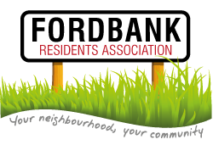
25th September 2014
Didsbury Sports Ground 7pm
Agenda
- Minutes of last meeting and matters arising.
- List of attendees.
Please complete by road and please add email addresses where appropriate.
- Update from Treasurer.
- Invited Guest: Councillor Jeff Smith
MMU Site Update.
- New RA Website.
Demonstration and how to access – Shaun.
- Invited Guest: Didsbury Civic Society- Steve Parle.
History of Didsbury Civic Society.
How they spend their time.
How we can work together.
Upcoming dates.
- Update from Chair.
Ward Coordination meeting.
Trees
Grants – new ones submitted by 31.8.14.
Allotment Society
- Invited Guest: Mickayla Police Community Liaison Officer.
Possible forming of ‘No Cold Call’ zone?
- Update from Secretary.
Noticeboard on Ford Lane?
Meeting with Mersey Valley.
Didsbury in Bloom.
- Social Event.
Any volunteers?
- Invited Guests: Councillors Carl Ollerhead and David Ellison.
Update on:
Roads - Dene Road completely refurbished
Ford Lane- has been assessed and large patch repairs completed and now on priority list from April 2015 for a complete resurface.
Lighting at end of Ford Lane.
- Social Media Committee Member.
- Invited Guest: DSG
Update on from DSG.
- Date of next meeting.
- AOB.

