Fordbank Residents Association – Didsbury Civic Society Meeting

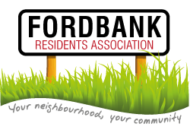
28th August 2014
Present:
Fordbank RA: Tony Butterworth, Rachel Dalton-Woods
CBD Design: Shaun

- Tony and Rachel gave their sincere thanks for Shaun for all his hard (and free!) work.
- Shaun has finished the website and given email addresses and accounts to Tony and Rachel.
- Shaun explained the various links he suggested for the website e.g. posts related to the current spate of burglaries on Dene Road, useful contacts e.g. handymen and approach Julian Wadden re: advertising.
- Shaun explained the process of adding extra links and setting up a new page of ‘our friends’.
- Tony has applied for a cash grant to help pay for Shaun’s services.

Actions.
Action | Who
Create a page for ‘our friends’ | Shaun
Add useful tradesmen contacts | Shaun
Contact Julian Wadden re advertising | RED
Add contacts for our friends | RED
Contact Mo re: DSG representative for next meeting and noticeboard | RED
Add local Councillors and MP to our friends page | RED
Apply for cash grant | TB

