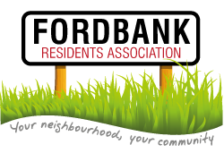
15th October 2015
Didsbury Sports Ground 7pm

We will being serving light refreshments from 7-7.15pm and the meeting will commence at 7.20pm.

Agenda
- Minutes of last meeting and matters arising.
- List of attendees.
Please complete by road and please add email addresses where appropriate.
- Update from Treasurer (ricmaxtayl@aol.com).
- Social Events from Social Secretary (ruth@ruthbradshaw.co.uk ):
- Update on Didsbury Festival
- Christmas Event
- Invited Guests: Councillors Carl Ollerhead (cllr.c.ollerhead@manchester.gov.uk) and David Ellison (cllr.d.ellison@manchester.gov.uk):
- Update on “Devo Manc” https://www.gov.uk/government/uploads/system/uploads/attachment_data/file/369858/Greater_Manchester_Agreement_i.pdf
- Local update
- Invited Guest: Mickayla Simmons (Mickayla.Simmons@gmp.police.uk)
- Update on local area
- Presentation from Chair (http://www.fordbankresidents.org.uk/ ):
- Health Update
- Presentation from Secretary (http://www.fordbankresidents.org.uk/) :
- Ward Matters Update
- Date of next meeting – January 2016:
- Annual Election of Officers
- Renewal of Annual Household Subs
- AOB.

