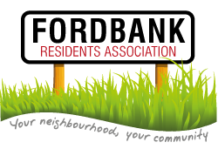

**Thursday 19th May**

**Didsbury Sports Ground 7pm**

**Agenda**

1. Minutes of last meeting and matters arising.
2. List of attendees.

Please complete by road and please add email addresses where appropriate.

1. Social Events:

* Summer Barbeque from Social Secretary ([ruth@ruthbradshaw.co.uk](mailto:ruth@ruthbradshaw.co.uk))
* Didsbury Festival from Green Member ([john@waterton.name](mailto:john@waterton.name))

1. Invited Guest: David Ellison (cllr.d.ellison@manchester.gov.uk):

* Local update

1. Update from Treasurer: Milly Taylor ([ricmaxtayl@aol.com](mailto:ricmaxtayl@aol.com)).
2. Invited Guest: Mickayla Simmons ([Mickayla.Simmons@gmp.police.uk](mailto:Mickayla.Simmons@gmp.police.uk)*)*

* Update on local area

1. Presentation from Chair <http://www.fordbankresidents.org.uk/> :

* Health Update
* Cash Grant

1. Presentation from Secretary <http://www.fordbankresidents.org.uk/>:

* Ward Matters Update

1. AOB.