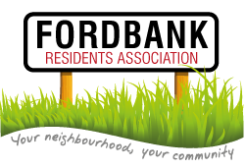
Thursday 19th May
Didsbury Sports Ground New Time – 8.15pm

Agenda
- Minutes of last meeting and matters arising.
- List of attendees.
Please complete by road and please add email addresses where appropriate.
- Social Events:
- Summer Barbeque from Social Secretary (ruth@ruthbradshaw.co.uk)
- Didsbury Festival from Green Member (john@waterton.name)
- Invited Guest: David Ellison (cllr.d.ellison@manchester.gov.uk):
- Local update
- Update from Treasurer: Milly Taylor (ricmaxtayl@aol.com).
- Invited Guest: Mickayla Simmons (Mickayla.Simmons@gmp.police.uk)
- Update on local area
- Presentation from Chair http://www.fordbankresidents.org.uk/ :
- Health Update
- Cash Grant
- Presentation from Secretary http://www.fordbankresidents.org.uk/:
- Ward Matters Update
- AOB.

