Fordbank Residents Association – Didsbury Civic Society Meeting

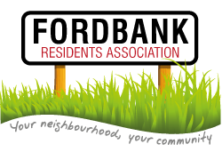
19th August 2014

Present:
Ford Lane: Tony Butterworth, Rachel Dalton-Woods
Didsbury Civic Society: Steve Parle

This meeting was to discuss the potential of joint future working between the two organisations and to fully understand Didsbury Civic Society role.
Steve described the Society – 50 years old next year and has many strands:
- Traders
- Parks
- In bloom
- Planning
- Carols and lights
- Heritage days
- Conservation
- Social
- Trips
- Festival
- Didsbury friends
- The Parsonage Trust
He agreed to talk at the next meeting on 25th September regarding these aspects and how we can get involved.
Didsbury Good neighbours is a different organisation which helps to assist the elderly through the use of volunteers and they run the Pavilion Café in Didsbury Park during the summer.

