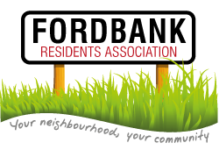
Please note change of date:
26th March 2015
Didsbury Sports Ground 7pm

We will being serving light refreshments from 7-7.15pm and the meeting will commence at 7.20pm.

Agenda
- Minutes of last meeting and matters arising.
- List of attendees.
Please complete by road and please add email addresses where appropriate.
- Update from Treasurer.
- Social Event Suggestions – led by Social Secretary.
- Neighbours Day
- Didsbury Festival – Saturday 13th June 2015
- Didsbury Gardens – Sunday 14th June 11.30-5.30pm – 1 resident already involved.
- Didsbury Arts Festival
- Quiz Night
- Invited Guest: Didsbury Good Neighbours.
- Presentation from Chair:
- Health Update
- New Elected Post – Council Liaison Officer
- Presentation from Secretary:
- Post Boxes
- Didsbury Village Clean
- Didsbury in Bloom – ways to support
- Fly Tipping
- Ford Lane Car Park
- Invited Guests: Councillors Carl Ollerhead and David Ellison:
- Update on Local Area
- Invited Guest: Councillor Jeff Smith:
- Update on MMU site, including the School.
- Date of next meeting.
- AOB.

