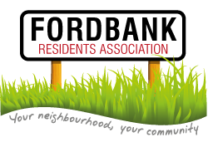
14th January 2016
Didsbury Sports Ground 7pm

Agenda
- Minutes of last meeting and matters arising.
- List of attendees.
Please complete by road and please add email addresses where appropriate.
- Social Events from Social Secretary (ruth@ruthbradshaw.co.uk ):
- Christmas Event Review
- Didsbury Festival
- Invited Guests: Councillors Carl Ollerhead (cllr.c.ollerhead@manchester.gov.uk) and David Ellison (cllr.d.ellison@manchester.gov.uk):
- Local update
- MMU site
- Pavements
- Invited Guest: Mickayla Simmons (Mickayla.Simmons@gmp.police.uk)
- Update on local area
- Presentation from Chair (http://www.fordbankresidents.org.uk/ ):
- Health Update
- Possible Cash Grant
- Presentation from Secretary (http://www.fordbankresidents.org.uk/) :
- Ward Matters Update
- Annual Election of Officers:
- Chair
- Secretary
- Social Secretary
- Treasurer and Renewal of Collection of Annual Household Subs
- Date of next Meeting – April 2016
- AOB.

