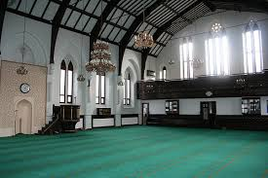

Short talk

Free refreshments

Guided tours

Q&A session

**No prior booking necessary**

For further information, contact:

**Tracey Pook 07464602434.**

**Date: SUNDAY 3RD MARCH**

**Time: 12PM-5PM**

**Address:** Manchester Islamic centre (Didsbury Mosque)

271 Burton Rd, West Didsbury, M20 2WA

(free parking available on site)

**You are invited to our**

**Mosque Open Day!**